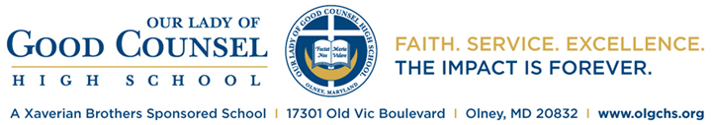

Advanced Placement and International Baccalaureate Program
Subject Offerings 2017-2018

AP Literature and Composition

AP Spanish Language
AP French Language

AP European History
AP Government and Politics:
Comparative
AP US Government and Politics
AP US History
AP World History
AP Psychology
AP Human Geography

AP Biology
AP Chemistry
AP Physics 1
AP Environmental

AP Calculus AB
AP Calculus BC
AP Statistics

AP Computer Science A

AP Studio Art: Drawing

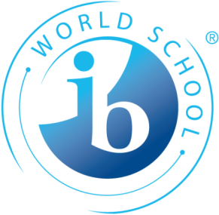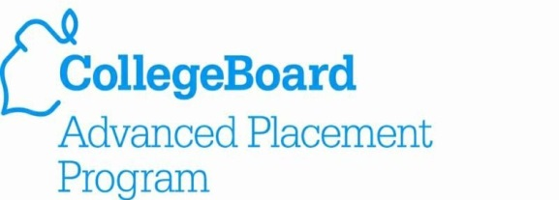
IB English A: Literature – Part 1 and Part 2
(HL and SL)*

IB Spanish ab Initio (SL)
IB Spanish B (SL and HL)
IB French ab Initio (SL)
IB French B (SL and HL)
IB English B (SL)

IB History (HL and SL)
IB Economics (HL and SL)
IB Psychology (HL and SL)
IB World Religions (SL)
IB Information Technology in a Global
Society (SL)

IB Biology (HL and SL)
IB Chemistry (HL and SL)
IB Physics (HL and SL)
IB Sports Exercise and Health (SL)

IB Math Studies (SL)
IB Mathematics (SL)
IB Mathematics (HL)

IB Music -Vocal and Instrumental (HL and
SL)
IB Theatre (HL and SL)
IB Visual Arts A (HL and SL)

IB Theory of Knowledge

*HL (Higher Level) denotes
240 hours of instruction.
SL (Standard Level) denotes
150 hours of instruction.

